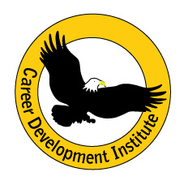

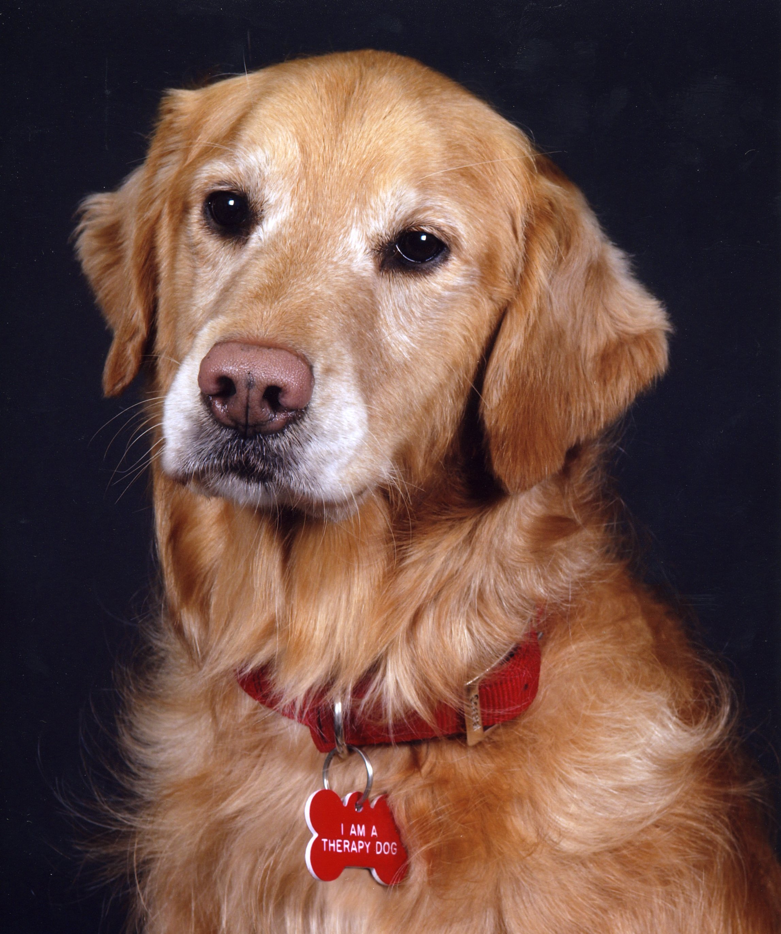
PRESS RELEASE

FOR IMMEDIATE DISTRIBUTION
A Pet Owners Primer…
“Living with, caring for, and loving your dog or cat”

Most of the information regarding the care and welfare of our animals has come from the pet industry (manufactures who are selling products), veterinarians (who are trained to treat illnesses), books (written with writer’s bias), the Internet (web searches & blogs) and our many relatives, friends, neighbors, and acquaintances. Have you ever considered that much of this information may be wrong?
Raritan Valley Community College through Career Development Institute is offering the first Pet Owners Primer…” Living with, caring for, and loving your dog or cat.” During this two days course, you will have the opportunity to learn from experienced professionals (Veterinarian, Animal Control Officer, Animal Rescuer, and Pet Owners) the fundamentals of what it takes to have a wonderful and rewarding life with your dog or cat. Course overview:

- Understanding Each Other… things you need to know!
Includes: animal human bond, responsibilities, benefits, dog and cat breeds & temperament, communication
- New Jersey Laws Regarding Dogs and Cats
Includes: licensing, vaccinations, leash laws, noise ordinances, minimum care requirements, hazards
- Making your home pet friendly
Includes: housing/crating/spacing, eliminations, transitioning, grooming, security, lifestyle impact
- Diet & Exercise
Includes: choosing foods, treats, exercise & play, mental stimulation, toys, aging
- Training/Behavior Modification
Includes: “the perfect pet”, expectations, housetraining, choosing a trainer, types of classes, socialization, “problems”, certifications
- Medical Care
Includes: rabies, spay/neutering, choosing a veterinarian, vaccinations, aging & senior care, emergencies,
financial planning & pet insurance
- Pet First Aid Certification
Includes: first aid for cats and dogs, CPR, wound treatment, emergency care
- Selecting a new or additional pet
Includes: Expectations, breed considerations, lifestyle effects, living situation, selection sources
The course will be held on two consecutive Saturdays, April 28th and May 5th 2012 at Raritan Valley Community College from 8:30 am to 4:30 pm each day. Enrollment is open to anyone interested in animals. There are no requirements for prior experience or training. Regardless of your past experience, anyone interested in bringing a dog or cat into their home should attend. Completion of the course and certification requires attendance at both classes.

Tuition for this program is $179, which includes all materials. Course registration can be accomplished through the college by calling 908-218-8871. Refreshments will be served. Please contact Career Development Institute with any questions that you may have.

Career Development Institute
732-821-6997 www.cditraining.org
